MARKET RESEARCH

1. Navigation Bar

Retrieved from : <https://play.google.com/store/apps/details?id=ca.ihsa.construction>

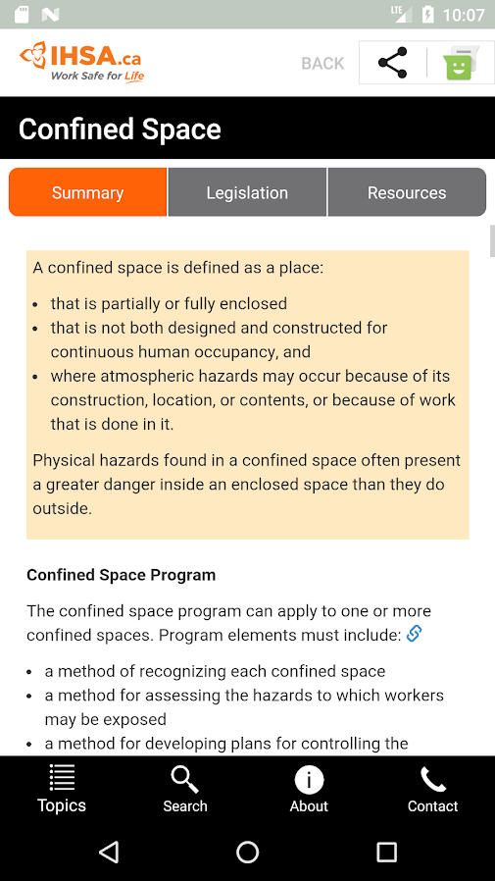We find this interesting navigation bar that could be used to separate the content in each section.

We find this search bar very important and helpful feature that can save time and give the desired information immediately.

1. Big Buttons and Icons

Retrieved from : <https://www.geoprosolutions.com/en-ca/>

The way the Buttons and Icons are displayed are very easy to understand, even a person with low English proficiency can easily understand the layout.

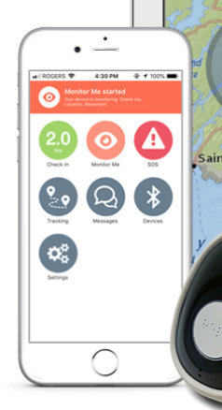 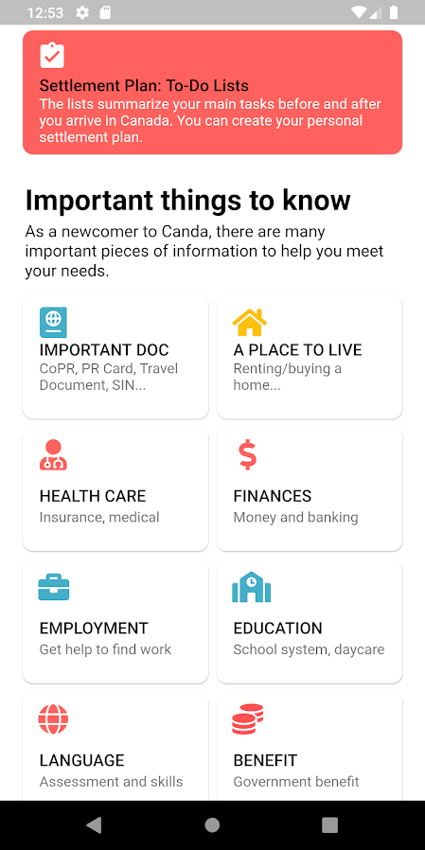

1. Incident Report Feature:

Retrieved from: <https://www.superiorglove.com/blog/top-apps-for-the-safety-professional>

We find this feature very important as if someone face any problem he/she can report that incident and can get timely help.

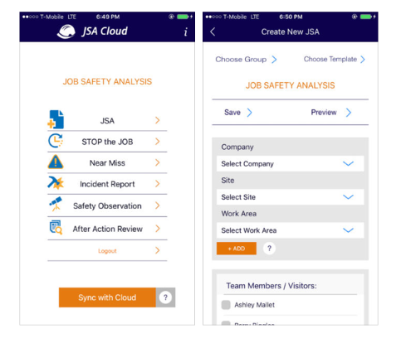

1. Offline Mode Feature

Retrieved from: <https://yalantis.com/blog/offline-mode-application/>

We find this feature to be one of the most important aspect of this application. In case of no-internet a person can still find helpful information from the app by using in offline mode.

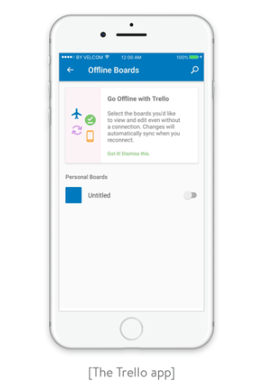

1. Multi-Lingual Feature

Retrieved from: <https://developer.android.com/training/basics/supporting-devices/languages>

We think that this feature can increase the usage around the globe as language plays an important role. A person can change the language he/she is comfortable in and can understand what to do in tough situations in an easy manner.

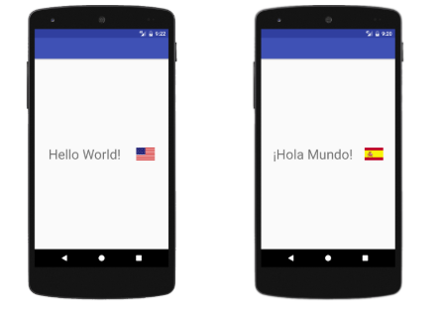

1. Feedback Feature

Retrieved from: <https://www.apptamin.com/blog/getting-feedback/>

We think this feature plays an important role in improving an app quality and functionality. So, adding this feature will let the development team know that where this app is lacking and there would be an immediate action on things that needs to be improve.

